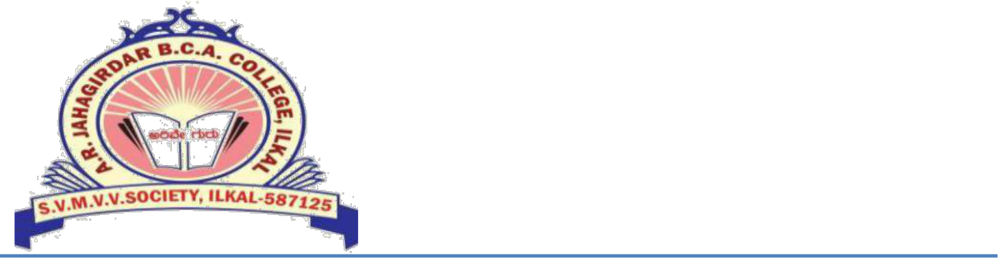

**J.R.A BCA COLLEGE,**

**ILKAL -587 200**

**Date:**

**TO WHOMESOEVER IT MAY CONCERN**

This is to certify that **Feedback redBus** has worked as a **Teacher Intern** in our college from **21st November 2022 to 25th February 2023**. During this period, he has taken both theory and lab subjects and has performed his/her duties with utmost dedication and sincerity.

Throughout his tenure, **Feedback redBus** has shown dedication, commitment, and professionalism towards his work. He has been punctual and responsible, and has demonstrated excellent teaching skills. His efforts have been appreciated by both the students and the faculty members.

Based on his performance, I can say that he has been an asset to our institution. We are glad to have had him as a part of our team and we wish him all the success in his future endeavors.

Sincerely,

Principal

**Signatures _____________________________**